Sew Deluxe Leg Form 4 part
Features & Options

- 10 adjusting wheels and fixed back length  - Adjustable neck with useful pin cushion  - Metal tripod stand with height adjustment and graduated hem measurements on central pole  - Shaped hip and thighs for pants/trouser fitting | - Off-set column to enable pants/trouser to hang straight  - Covered with nylon, foam backed fabric for easy pinning and marking of garment  - Calibrated pin grip for marking the hemline  - available in in two sizes
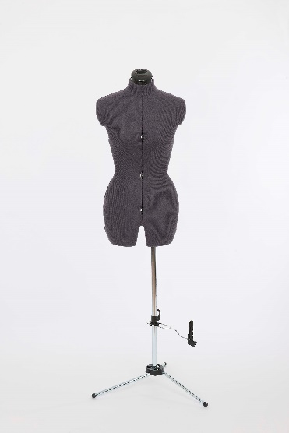
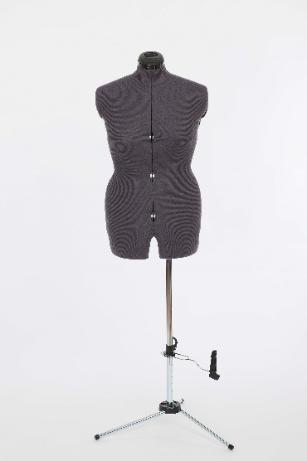

 | MEASUREMENTS
SIZE | A | B
Bust | ins: 33 - 41  cms: 84 – 104 | ins: 39 - 46  cms: 99 – 117
Waist | ins: 25.5 – 33.5  cms: 65 – 85 | ins: 32 - 39  cms: 81 – 99
Hips | ins: 36 - 44  cms: 91 – 111 | ins: 41 - 49  cms: 104 – 124
Back length | ins: 14.5  cms: 37 | ins: 15  cms: 38
Height (max) | ins: 74  cms: 188 | ins: 75  cms: 190

Adjustoform Products Ltd, Units 1 & 2 Mace Lane Industrial Estate
Ashford, Kent TN24 8EP, United Kingdom
Tel: +44 (0)1233 625 227, Fax: +44 (0)1233 612 352
Email: sales@adjustoform.com Web: www.adjustoform.com

***** 2 YEAR GUARANTEE ON FAULTY MATERIAL OR MANUFACTURE *****

